The Spartanburg Journal
Spartanburg, South Carolina - January 2006
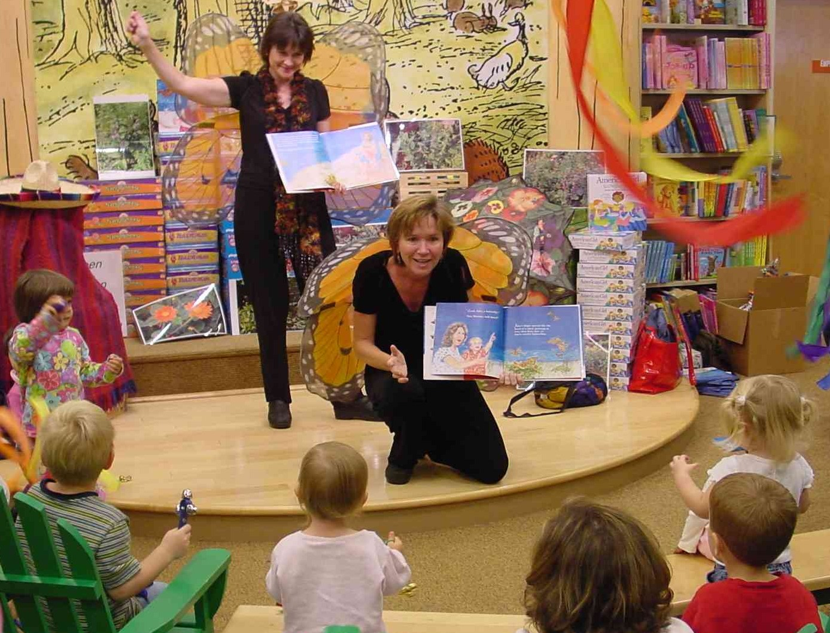
Trustees' Book Wins National Award
By Lyn Riddle  STAFF WRITER  Jake and the Migration of the Monarch, a children's book by Greenville County School Trustee Crystal Ball O'Connor, has received the Teacher's Corner Award of Excellence for its teaching resources and Web site.  In addition, Monarch Publishers was awarded a $29,000 Hollingsworth Grant to allow the company to provide the book and offer educational enrichment opportunities for disadvantaged children and families. The award also will be used for professional development for the teachers who serve disadvantaged children.  Teachers Corner is an online teacher resource Web site that gives monthly awards to other Web sites dedicated to teaching.  O'Connor said the book is about to go into a second printing.  "We had planned to sell the first printing of our book in three years. Instead we are having the reorder within the first year!" she said.  O'Connor and illustrator Valerie Hollinger, a former Greenville County School Trustee, | have made appearances at 30 East Coast bookstores and 16 teacher conferences and have visited 40 schools.  O'Connor and Hollinger became friends while serving on the school board. They decided to launch Monarch Publishers after a simple conversation over coffee at Hollinger's new apartment turned to a discussion of hopes and dreams. O'Connor had an idea for a children's book and Hollinger had the talent to illustrate it.  O'Connor formed the basis of the story during a visit with her husband's parents when her now 4-year-old son Jake was an infant. She was sitting with Jake when a monarch butterfly flew by, then another and another until she realized she was watching the annual rite of butterflies making their way to Mexico for the winter.  "I realized I was seeing something extra-ordinary," she said. When dusk fell, she went inside and wrote down her feelings.  She started researching the children's book business and in the fall of 2001, during one of her three-times-a-week overnight stays with her aging parents, she began writing. Months passed. | She'd write and rewrite. She'd set it aside. She'd read more children's books.  What she came up with is a timeless story of how one generation influences the next. Jake, a preschooler, is watching the migration with his mother, who sets aside her busy schedule to spend time with her son. The underlying lesson centers on the need to save the butterfly habitat in Mexico but also speaks movingly about the ties that bind generations of butterflies and - by extension people - together.  In school visits, Hollinger and O'Connor don wings to perform a skit about butterflies and read from the book.  "I'd like to help children appreciate the part they can play in protecting the environment, and to make a significant contribution to high-quality children's literature," O'Connor said. "Most importantly, I want to celebrate the extraordinary love between parents and children across generations."

