Greenville Magazine
Greenville, South Carolina - March 2006
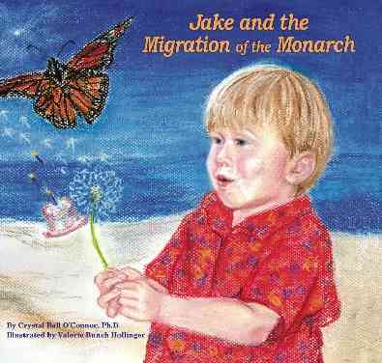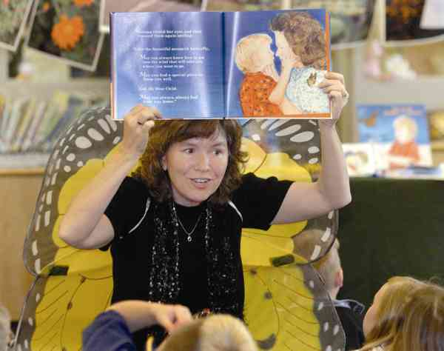
My Greenville Profile of Crystal Ball O'Connor
By Heather Magruder  Dr. Crystal Ball O'Connor recalls a sunny afternoon during which she relaxed in a comfortable chair outside with her youngest child on her lap. The afternoon was one of those peaceful times, spent one-on-one with a child; one of those days that can be so elusive for most families. Parents typically carry the memory of such days in the back of their minds, ready to pull them out when the weekday gets a bit too harried or children fight a little harder than usual over homework or eating their vegetables or whatever else might get in the way of harmonious family relationships. O'Connor is no different from the rest of us in that way. The memory of that afternoon with Jake on her lap is a precious one that she will hang onto. The difference between O'Connor and the most of the rest of us is that, in addition to making a memory, O'Connor has made a children's book, complete with its message of love, nurturance, family ties and the importance of preserving nature, out of that one experience.  While Jake and his Mom sat together that afternoon, a monarch butterfly happened by. As O'Connor told Jake the story of the butterfly's journey, the seed of the children's book planted itself. At the time, O'Connor was caring for her aging parents as well as her children. "I wrote in my old family home," O'Connor recalls, "listening out for Mom and Dad." | Although Jake and the Migration of the Monarch began that afternoon with Jake spotting the monarch butterfly, it is more than that. That O'Connor crafted a tale that links us with nature as well as linking the generations of family should come as no surprise to those who know the author. Not only is O'Connor an involved mother of three who was raising young children and caring for aging parents at the same time, she is also a former director of the Georgia Council on Aging and a current Greenville County Schools trustee.  "The book is about nature," she says. "It's about helping children preserve and protect the gifts of family, nature and literacy. It's about the universal message of coming home and always finding your way back home."  As with any excellent children's book, the illustrations are as important as the text. With this in mind, O'Connor knew just where to turn. She and Valerie Bunch Hollinger had known each other for some time, collaborating as school board trustees and finding common ground in other areas as well. "When I saw her portraits, I knew she had to illustrate the book," O'Connor says. She asked Hollinger to read the story and decide if illustrating the book would be of interest.  "We both went into high gear," O'Connor says of their collaboration.  When the book came out a year ago, the pair estimated that it would | take three years to sell all of their first printing. Now a year later, they are ready to come out with the second printing, which has a new dust cover and comes with a CD. O'Connor and Hollinger are also working on a second book.  "We are as excited about the second book as we were about the first," says O'Connor. She is not only excited about having another book on the shelves, but is also thrilled that the books "speak to the power that women have in preserving their family stories."  If you would like to see how O'Connor and Hollinger have turned one family's story into a book that has received accolades from readers of all ages as well as from organizations such as the National Center for the Study of Children's Literature, head down to local bookstores and pick up a copy or go to www. MonarchPublishers.com.

