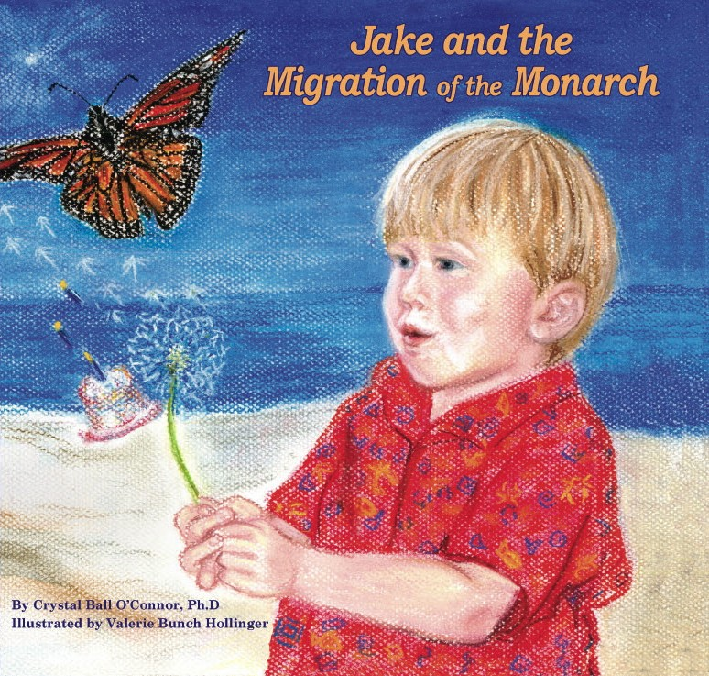


www.MonarchPublishers.com
Outstanding teacher guides and family activities to download free of charge.

