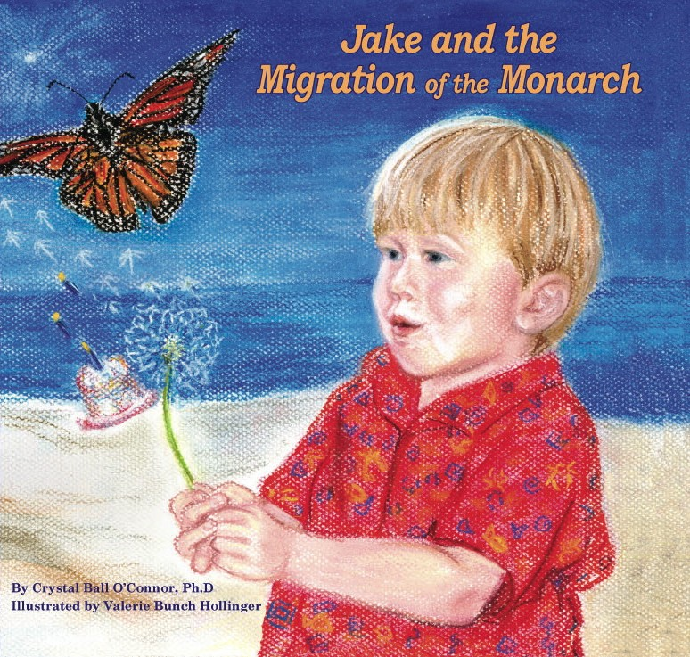


www.MonarchPublishers.com
Outstanding teacher guides and family activities to download free of charge.

Monarch Publishers

400 North Main Street, #405
Greenville, South Carolina 29601
www.MonarchPublishers.com
864.979.8554

Dear Colleague:

Jake and the Migration of the Monarch is more than a children’s book. It is an exploration of the world around us and the world beside us, an intergenerational journey of finding our way home.

Jake is a little boy who notices a stream of butterflies soaring past his island home. He gathers his mother to his side and the two watch as this miracle of nature unfolds, cementing their bond and realizing their own place in the world. The monarchs position themselves in the wind to find their way home, just as children do with their own families.

“That image came to me from my father, who was a pilot in World War II,” said O’Connor. “It is a universal truth that we all search for our place in the world and are comforted by the ever-open arms of home.”

Author Crystal Ball O’Connor, Ph.D. received her doctorate in Education and Human Development from Peabody College for Teachers, Vanderbilt University. She and illustrator Valerie Bunch Hollinger, MSW and portrait artist, have worked for years to improve educational opportunities for young children, with particular concern for a rich arts environment and early literacy. O’Connor and Hollinger have traveled a fascinating journey from Greenville County school board members to book publishers.

Their publishing company - Monarch Publishers www.monarchpublishers.com – was started to bring this delightful story and related educational resources to the public. And they intend to keep going with more books and those of other children’s book authors.

They began with a dream and forged ahead, learning as they trudged along, and ended up a high-quality book that reminds readers of such timeless tales as The Little Prince and The Talking Eggs.

We recognize the contribution you make to high quality children’s literature and are honored by your close consideration of Jake and the Migration of the Monarch. Please contact us if you need additional information at 864-979-8554 or cbjwo@aol.com.

Sincerely,
Karen

Karen Goot
Master of Arts in Teaching, Northwestern University
Business Manager


Charleston, South Carolina - October 20, 2005

Children’s book exudes warmth
By Fran Hawk

‘J ake and the Migration of the Monarch" by Crystal Ball O'Connor, Ph.D., will be the featured children's book at the Mount Pleasant Barnes & Noble at 11 a.m. Saturday. When I describe this picture book as "sweet," I mean that it's gentle and loving. The illustrations by portrait painter Valerie Hollinger add a soft, warm radiance to the text.
In addition to being sweet, "Jake and the Migration of the Monarch" is entertaining and educational for both parents and children. Jake and his mom are sitting on their porch at the beach when they realize they're in the midst of the autumn migration of the monarch butterflies. As they
watch the countless butterflies, Jake's mama gently explains the migration process. She relates the life cycle of the monarch to the life cycle of families. She says, "Just as your parents and grandparents and great-grandparents help set a path for you, the butterflies do the same thing."
In the back of the book, there's a family tree to complete as well as a page called "Monarchs and Me ..." that gives more information about the connections between butterflies and people.
Readers are referred to the Web site, www.monarchpublishers.com "to learn more about the world of monarch butterflies." This is an excellent site for both parents and teachers
because it provides myriad ways to extend learning into physical activities, drama, language arts, math, music, science, social studies and visual art. There are things to do, make and grow. There's a list of places to go, and an invitation to submit your own "stuff" to the site.
The whole concept of "extending" learning has been used in schools for a long time. The book makes this concept readily available to families.
The book serves as the beginning step into a whole world of knowledge and activities.

Contact Fran Hawk at franbooks@yahoo.com.

The Greenville News
Greenville, South Carolina - Sunday, October 30, 2005

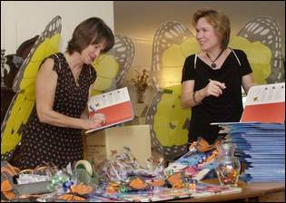

Monarch magic
Greenville women make their own migration
to the field of children's literature

By Lillia Callum-Penso
STAFF WRITER
lpenso@greenvillenews.com
It's Wednesday morning, typically a working day for Valerie Bunch Hollinger and Crystal Ball O'Connor. The two women, who have served on the Greenville County school board, and who as of this spring became children's book publishers, relish these weekly meetings when they can strategize and drink lattes in the heart of Hollinger's upper-floor apartment.
The sharp autumn light illuminates Hollinger's polished kitchen and the shiny cappuccino machine at which she stands, frothing.
"She makes the best coffee," O'Connor says. "That's why I like working here."
That, and the fact that O'Connor's house is currently holding her and her husband, their three kids, her mother and her great-aunt. But you won't hear O'Connor complain. She says it's just fodder for more stories.
O'Connor's first published story, "Jake and the Migration of the Monarch," began as a moment of wonderment four years ago while she was on vacation at the coast, sitting on a porch. She held her newborn son Jake in her arms, drifting into introspection. Then, the butterflies moved in, fluttering past mother and son in a majestic hail of flapping wings.
"They just kept coming," O'Connor recalls. "So I just started counting them. I knew it would mean something special for Jake."
O'Connor was right, but at the time she wasn't sure how that "something special" would manifest itself.
Since that day at the beach, she has, in a sense, gone on her own migration. She and Hollinger teamed up as writer and illustrator, respectively, and the two went from forming a publishing company, Monarch Publishers, to developing a Web site, to collaborating on creating a curriculum to integrate the book into classrooms. The women have spent endless amounts of time appealing for spots at teacher conferences and educational talks.
Now, standing in Hollinger's kitchen, that loaded moment seems distant to O'Connor, but it hasn't faded. After she began researching the patterns of monarch migration, the story emerged. At the time, O'Connor was also caring for her aging parents and was often up in the middle of the night; thus, it was the perfect convergence of life and research.
"Seeing it, having such a profound feeling about it and then having the opportunity that was set up in that unique way to sit in my family home and make the tea in the middle of the night and sit up," O'Connor says, "it just happened very naturally.
"It was definitely a unique writing environment that was very, very conducive to having the words come out like I wanted them to.”

In a way, Hollinger and O'Connor have done things in reverse, moving from administrative desks to classroom carpet.
Though Hollinger was certified in secondary education, she ended up getting a master's in social work, and art had been a longtime hobby.

"They have this great story that's about so much more than butterflies. It can be about families, it can be about coming home, it can be about reading with your children. … It's amazing how this book took on such a life of its own."
― Sharon Kazee, Dean of the Governor’s School for the Arts and Humanities
O'Connor was director of the Georgia Council on Aging before moving to South Carolina to care for her parents.
The women met on the school board, where Hollinger served two terms. O'Connor will finish her last term at the end of this year. Thus, it is their book that has landed them in the classroom.
"Neither of us had an idea of where this might lead," O'Connor says. "We just naively ..." She pauses, mulling over exactly what has transpired in the past several months.
"We're learning the way we want children to learn," O'Connor continues. "Each time we get to one point, it gives you a new opportunity to get to a deeper understanding."
The two mothers are no strangers to hard work, but since the release of their first book in May, Hollinger and O'Connor's lives have been a whirlwind of facts, figures and day-by-day learning.
To hear them tell it, they started their own publishing company simply because they wanted to be their own bosses. And, in order to fulfill their motto of "Helping children preserve and protect the gift of family, nature and literacy," starting their own company seemed like the only logical option.
"It's so great to wake up in the morning and think, 'Oh, I can work on whatever I want to work on today about this,'" O'Connor says. "There are so many wonderful paths to take with it."
But in keeping with their emphasis on education, they wanted the book to fit into classrooms as well.
So they enlisted the help of Sharon Kazee, dean of the Governor's School for the Arts and Humanities.
Kazee developed a companion curriculum that pertains to almost all subjects and fits within the parameters of state and federal standards.
Making a book into a teaching tool can be tricky, according to Michelle Martin, an associate professor in children's and adult literature at Clemson University.
"One mistake people who don't come from a writing background make when they are working on writing a children's book is that oftentimes the lessons are so in your face," Martin says.
"Even if it's an educational book or scientific book or something intended to teach, if it's didactic and preachy, then kids know. Kids are savvier than we give them credit for being. They can see through that."
Kazee agrees. She says part of the reason "Jake and the Migration of the Monarch" is such a good book is because it is a teaching tool that grew from a story.
The curriculum uses songs to teach connections between humans and monarchs and large maps to teach migratory patterns and to impart geography. Skits are also used to illustrate the monarch lifecycle, as well as to show how and why they migrate on a certain path.
"They have this great story that's about so much more than butterflies," Kazee says. "It can be about families, it can be about coming home, it can be about reading with your children. What we did was look at what we could do with this book that was creative.
"It's amazing how this book took on such a life of its own."
Whitney Blake, community relations coordinator for Barnes & Noble in Spartanburg, discovered the monarch duo at an educators' conference and was struck by Hollinger's and O'Connor's unique presentation. She booked them for the store's teacher appreciation day, and they sold 41 copies of the book.
Since that time, Blake says, she has placed an order for their book almost every week.
Hollinger and O'Connor laugh freely. It characterizes their time together, and it might be the reason their book is more than simply a project.
"It has taken over our lives," admits Hollinger, catching O'Connor's gaze as if she just told an inside joke. Then the punch line.
"When Crystal asked me to illustrate, I didn't know I'd be a driver and a singer and a dancer and a performer and the shipping department, too."
It would appear that their unique product and their approach to selling has worked well. They are fast approaching the 2,000 mark. Their three-year plan to sell out their initial printing of 5,500 has been shortened. Now, they anticipate selling out in one year.
O'Connor and Hollinger had planned to spend the morning hammering out the details of their fast-growing number of school appearances, book signings and conference presentations, but they get sidetracked. With their butterfly wings on, they dive into their presentation, a song and dance number that teaches the migratory pattern of monarchs.
"Yes, it is a long way, but we have no need to fear," the two sing as if they were each other's audiences. "Just look for leafy green signs that say butterflies are welcome here."
Then, they break into the "Green Song," "Green, green, green, green ..."
Laughter ensues.
"We have fun," O'Connor says, with full confidence that two adult women dancing and singing about butterflies is nothing but natural. "We would never work this hard if it weren't fun."
Watching the two interact, you can't help but think they don't even need an audience.

News from: |  |  | 400 North Main St. #405  Greenville, SC 29601  fax 864-235-6103
 | Contact: Crystal Ball O'Connor  Phone: (864)979-8554  Email: cbjwo@aol.com | FOR IMMEDIATE RELEASE
More than an enchanting tale...

There is a mystery to the South Carolina coast that many authors have attempted to explain. The marshes, the tides, the unknown, all capture the imagination.
Jake and the Migration of the Monarch is set in this place and describes a day when a little boy full of wonder notices monarch butterflies fluttering past his island home. He and his mother set aside the routine to watch this miracle unfold and in the doing further strengthen their bond.
It is a timeless tale of the ties that bring together generations, all longing for a place to belong, the place called home.
But this book is more than an enchanting tale. It is also a science lesson. Monarchs migrate each year from the northern United States to Mexico. West of the Rocky Mountains, monarchs migrate toward the Pacific and spend the winter in California and northern Mexico.
In captivating prose, Jake and the Migration of the Monarch paints a picture of this journey, educating children about the interdependence of man with nature. The destruction of the native fir forests in Mexico and its affect on butterflies is noted in the book, gently encouraging children to look around them to see what they can do to make the world a better place.
It teaches them that milkweed is the food monarch must have to survive because it protects them against predators. And it teaches them that at the end of the winter, life begins anew as the monarchs begin their journey home.
Former Secretary of Education Richard W. Riley describes the book as “educational and heartwarming, a pleasure for readers of all ages.”
Author Crystal Ball O’Connor, Ph.D. and illustrator Valerie Bunch Hollinger met as members of the Greenville County School Board. Their collaboration brought about the book as well as a publishing company, and outstanding educational programming – Monarch Publishers (www.monarchpublishers.com) – that will publish future O’Connor-Hollinger titles as well as other children’s book authors.

What people are saying about
Jake and the Migration of the Monarch
"A pleasure for readers of all ages, the story connects Jake with his mother as his teacher in such a warm and loving manner and includes a heartfelt inter-generational message. Excellent resource in the classroom as well as at home.” Richard W. Riley, Former U.S. Secretary of Education
“Stunning book,
a real treasure. It has already become a library favorite! The story weaves literature the arts, science, nature and social studies together in this heart-warming and fascinating picture book. Mesmerizing for students and adults.” Sally Nuss, Media Specialist, Taylors Elementary
“I recommend this impressive, creative book because it is informative, engaging, and provides opportunities for active learning. Most importantly, it makes the learning of science fun!” Randy Dozier, Ph.D. Superintendent of Education, Georgetown County Schools.
“Marvelous book! Our children and teachers agree that the captivating journey in the book and in your school appearance is the best EVER!” Marci Yates, Media Specialist, Mason Preparatory School.
“Recently our store had the privilege of having Crystal O’Connor and Valerie Hollinger join us for a truly meaningful evening of music, fun, and storytelling with their wonderful book, Jake and the Migration of the Monarch. This book about the wonder of life’s journeys will be a treasure for children and families. Warm, inviting, first class all the way!“ David Walker, Barnes & Noble Manager

“This beautiful book enhances a child's scientific curiosity as well as his appreciation for the arts. The story, art and music are appealing and charming.” Dorothy Lippitt, Twinsburg, Ohio
"A beautiful story about life and love and finding a home place! Captures the special closeness between mother and child, reminds us of the importance of family, and invites us to explore one of the marvels of nature—monarch butterfly migration.” Tunky Riley, Former First Lady of South Carolina, Board Member of Alliance for Quality Education
Selected for recognition of merit by South Carolina Center for Children’s Books and Literacy.

“A timeless story certain to become a family favorite. The perfect gift to celebrate the birth of a child, to share with an older child, or to present to a grandchild or graduate.” Emma Watson, Fellow, Bread Loaf School of English
“To accompany this lovely story, the author and illustrator have put together an exceptional web site www.monarchpublishers.com with superior teaching resources.” Sharon Kazee, Dean of the SC Governor’s School for the Arts
Selected for review in READING MATTERS, Journal of International Reading Association. Assistant Professor of Reading Education Jonda C. McNair Ph.D. recognizes the book, CD and teaching resources featured on web site.
“Most of the time, teachers have to choose between books that offer high quality educational content and books that entertain and delight children. With Jake and the Migration of the Monarch, we don’t have to choose. It does both!” Christina Hunter, Greenville County Teacher of the Year.

“I love the story and the illustrations are great. My favorite part is when all the butterflies fly all together. The book makes me feel grateful and happy.”
Elementary School Student Iman Qatawi,

“I have taught school for more than 30 years and I highly recommend this wonderful book to lovers of children and nature. The author and illustrator gave the best school presentation I have ever seen.” Sara Doolittle, Teacher, Simpsonville Elementary

“A great learning tool for our treasure's of today and our preservation-minded citizens of tomorrow!” Joe Ball, Trust for Public Land, Georgia

“Grandparents, parents and children will benefit from sharing this captivating book again and again. The family tree is an added treasure to complete with loved ones!” Carla Eichler, Ed.D. Principal ILR, Nashville TN

“This has been the most valuable professional development in my teaching. It's wonderful to be able to leave a session with an extraordinary children’s book and ideas that you're eager to share with team members and, most importantly, students. “ Georgetown Teacher Evaluations, Tanieka Greggs
Crystal Ball O'Connor, Ph.D. Biography

CRYSTAL BALL O’CONNOR, lives in Greenville, South Carolina with her husband and their three children. She attended Agnes Scott College and holds her doctorate in Education and Human Development from Peabody College for Teachers at Vanderbilt University. She is the Former Director of the Georgia Council on Aging and a current Trustee on the Greenville County School Board. Her captivating text combines her interests in family connections at every age and in the joys of storytelling.

Valerie Bunch Hollinger Biography

VALERIE BUNCH HOLLINGER lives with her husband Wayne in Greenville, South Carolina, where she has served two terms on the Greenville County Schools Board of Trustees and raised two children. She received her BA from Newberry College and her Masters in Social Work from USC in Columbia. Best known for her portrait work, this is her first illustration of a children’s book. Her love of children, the arts and the beauty of nature are evident in her vibrant colors and imaginative expressions in perfect harmony with the text.

